**Thiết kế giao diện cho UC - Đặt hàng**

1. **USER INTERFACE DESIGN**
   1. **Creating screen images**

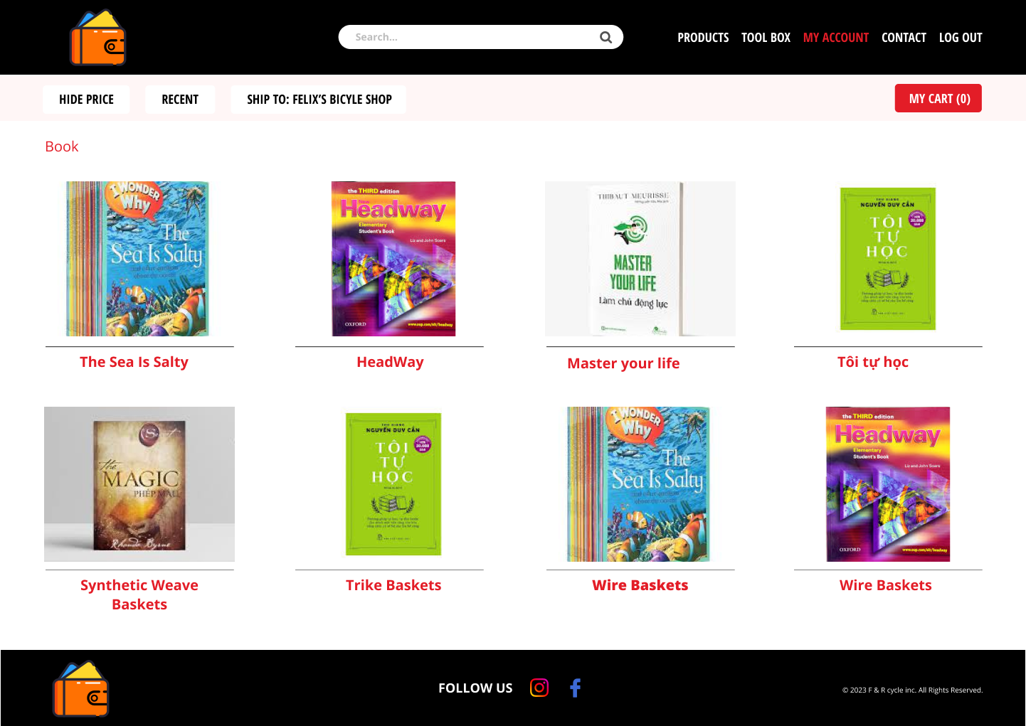

* 1. **Creating a screen transition diagram**

* 1. **Creating screen specification**

|  |  |  |  |  |  |
| --- | --- | --- | --- | --- | --- |
| **AIMS** | | Date of creation | Approved  by | Reviewed  by | Reviewed  by |
| screen specification | View cart screen | 04/11/2023 |  |  |  |
|  | | **Control** | **Operation** | **Function** | |
| Area to display list product | Initial | Display list product | |
| Area to display total price | Initial | Display total price | |
| Area to display button on bottom | Click | Navigate screen | |
| Remove Button | Click | Remove product from cart | |
| Button of Qty Column | Click | Change number of product | |

1. **SYSTEM INTERFACE DESIGN**
   1. **Place order**

* 1. **Vnpay**

